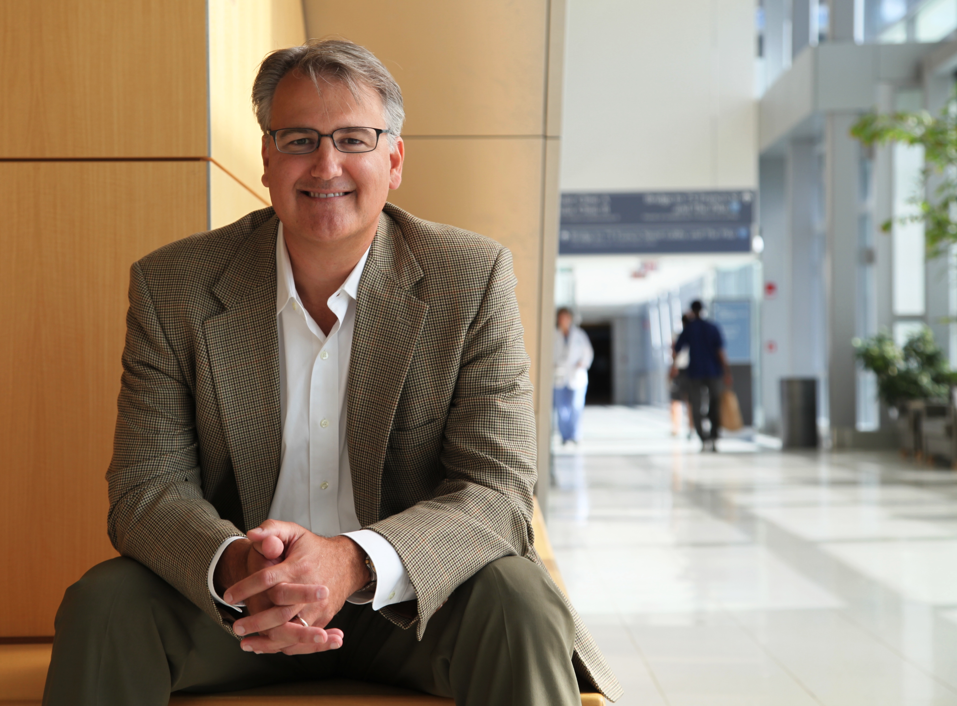




Robert M. Plenge, MD, PhD
Vice President, Merck Research Laboratories (MRL)
Worldwide Head, Genetics and Pharmacogenomics (GpGx)

____________________________________________________________________________________

Robert is Vice President at MRL in Boston, MA. He is founder and worldwide Head of the newly created Department of Genetics & Pharmacogenomics (GpGx). His Department, which is part of Early Development and Discovery Sciences (EDDS) under the direction of Dr. Rupert Vessey, is responsible for genetics and pharmacogenomics strategy throughout Merck’s entire pipeline – from early discovery to late-stage clinical development. Further, Robert is co-Chair of the Early Discovery Council (which oversees pre-lead optimization research programs); serves a key leadership role at the Boston MRL site, including external research opportunities; and is on the Steering Committee for the Merck-Singapore research collaboration.

Prior to joining Merck in July 2013, Robert served as Director of Genetics & Genomics in the Division of Rheumatology, Immunology and Allergy at Brigham and Women’s Hospital; Assistant Professor of Medicine at Harvard Medical School; and Associate Member of the Broad Institute of MIT and Harvard. His academic research focused on genetic and genomic underpinnings of complex human disease, with attention to immune-mediated diseases such rheumatoid arthritis (RA). He led multi-disciplinary teams that: identified new genetic risk factors for RA and other complex traits; performed functional studies of risk alleles to understand fundamental disease mechanisms; analyzed clinical data from electronic medical records (EMR) for discovery research in collaboration with i2b2; and investigated pharmacogenomic predictors of efficacy and toxicity as part of the NIH-funded Pharmacogenomic Research Network (PGRN). His original research has been published in Nature, New England Journal of Medicine, Science, Nature Genetics, and other top-tiered medical journals.

Robert graduated cum laude with a Bachelor of Science from the University of California, San Diego in 1992; received his MD and PhD degrees from Case Western Reserve University in 2000 (thesis advisor Hunt Willard); completed his Internal Medicine residency as Molecular Medicine Fellow at University of California, San Francisco in 2002; and served as rheumatology fellow at Brigham and Women’s Hospital from 2002-2006 and post-doctoral research fellow at the Broad Institute of MIT and Harvard from 2003-2007 (advisor David Altshuler). Between 2007-2013 he was on the faculty of Harvard Medical School and an Associate Member of the Broad Institute while practicing clinical rheumatology and running a research laboratory at Brigham & Women’s Hospital.

In recognition of his accomplishments, Robert has received numerous awards, including: Pre-doctoral Clinical Award from The American Society of Human Genetics (1995); The Young Investigator Award from the Department of Medicine at Brigham and Women’s Hospital (2008); Career Award for Medical Scientists from the Burroughs Wellcome Fund (2008); and election to The American Society for Clinical Investigation (2012).

He lives with his wife and three daughters in Wellesley, MA. He enjoys outdoor activities, socializing with friends and family, and participating in any activities that his kids want him to do.

